# JOBSHEET 1

# ALGORITMA DAN STRUKTUR DATA



MUHAMMAD DAFFI FIROS ZAIDAN 244107020182

TI 1E

# PROGRAM STUDI D-IV TEKNIK INFORMATIKA JURUSAN TEKNOLOGI INFORMASI

# POLITEKNIK NEGERI MALANG

# 2024

1. **Praktikum**
   1. **Praktikum Pemilihan**

-Kode Program

import java.util.Scanner;

public class Jobsheet1 {

    public static void main(String[] args) {

        Scanner scanner = new Scanner(System.in);

        System.out.println("Program Menghitung Nilai AKhir");

        System.out.println("=======================");

        System.out.print("Masukkan Nilai Tugas: ");

        double nilaiTugas = scanner.nextDouble();

        System.out.print("Masukkan Nilai Kuis: ");

        double nilaiKuis = scanner.nextDouble();

        System.out.print("Masukkan Nilai UTS: ");

        double nilaiUTS = scanner.nextDouble();

        System.out.print("Masukkan Nilai UAS: ");

        double nilaiUAS = scanner.nextDouble();

        System.out.println("==================");

        System.out.println("==================");

        if (nilaiTugas < 0 || nilaiTugas > 100 || nilaiKuis < 0 || nilaiKuis > 100 ||

            nilaiUTS < 0 || nilaiUTS > 100 || nilaiUAS < 0 || nilaiUAS > 100) {

            System.out.println("nilai tidak valid");

            return;

        }

        double nilaiAkhir = (0.2 * nilaiTugas) + (0.2 * nilaiKuis) + (0.3 * nilaiUTS) + (0.3 * nilaiUAS);

        String nilaiHuruf;

        if (nilaiAkhir >= 80 && nilaiAkhir <= 100) {

            nilaiHuruf = "A";

        } else if (nilaiAkhir >= 73) {

            nilaiHuruf = "B+";

        } else if (nilaiAkhir >= 65) {

            nilaiHuruf = "B";

        } else if (nilaiAkhir >= 58) {

            nilaiHuruf = "C+";

        } else if (nilaiAkhir >= 50) {

            nilaiHuruf = "C";

        } else if (nilaiAkhir >= 39) {

            nilaiHuruf = "D";

        } else {

            nilaiHuruf = "E";

        }

        System.out.printf("nilai akhir: %.1f\n", nilaiAkhir);

        System.out.println("Nilai Huruf: " + nilaiHuruf);

        System.out.println("==================");

        System.out.println("==================");

        if (nilaiHuruf.equals("A") || nilaiHuruf.equals("B+") || nilaiHuruf.equals("B") || nilaiHuruf.equals("C+")) {

            System.out.println("SELAMAT ANDA LULUS");

        } else {

            System.out.println("TIDAK LULUS");

        }

    }

}

-Output

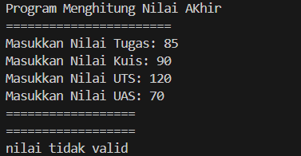

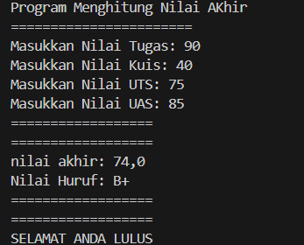

* 1. **Praktikum Perulangan**

-Kode Program

import java.util.Scanner;

public class Jobsheet1 {

    public static void main(String[] args) {

        Scanner scanner = new Scanner(System.in);

        System.out.print("Masukkan NIM: ");

        String nim = scanner.nextLine();

        int n = Integer.parseInt(nim.substring(nim.length() - 2));

        if (n < 10) {

            n += 10;

        }

        for (int i = 1; i <= n; i++) {

            if (i == 6 || i == 10) {

                continue;

            }

            if (i % 2 == 0) {

                System.out.print(i + " ");

            } else {

                System.out.print("* ");

            }

        }

        System.out.println();

        scanner.close();

    }

}

-Output



* 1. **Praktikum Array**

**Kode Program**

**Output**

* 1. **Praktikum Fungsi**